Written Homework - Weiss Chapter 2

1-(2.1): Order the Following and Indicate which functions grow at the same rate.
Original order given: N, √N, N^{1.5}, N², N logN, N log logN, N log² N, N log(N²), 2/N, 2^{N}, 2^{N/2}, 37,
N² logN, N³

2/N, 37, √N, N, N log logN, N logN, N log(N²), N log²N, N^{1.5}, N², N² logN, N³, 2^{N/2}, 2^{N}
Same Rate: N log N and N log(N²)

2-(2.6): In a recent court case, a judge cited a city for contempt and ordered a fine of $2 for the first day. Each subsequent day, until the city followed the judge’s order, the fine was squared (that is, the fine progressed as follows: $2, $4, $16, $256, $65, 536, . . . ).
a. What would be the fine on day N?
b. How many days would it take the fine to reach D dollars? (A Big-Oh answer will do.)

- The fine on day N would be 2^{2^(n-1)}. Side Note: Word will not let me do exponent of exponent, hence the notation I used.
- In Big-Oh, it would bet at worst O(log(log))

3- Give an analysis of the Big-Oh running time for each of the following program fragments:
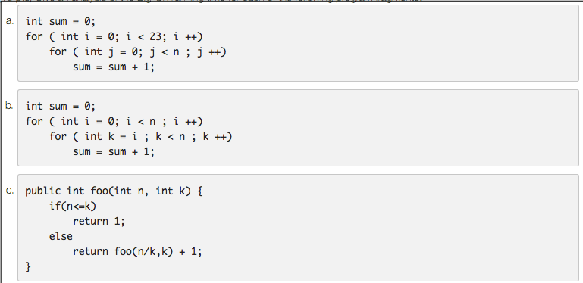

- T(N) = O(N)
- T(N) = O(N²)
- T(N) = O(N)

4-(2.11) An algorithm takes 0.5 ms for input size 100. How long will it take for input size 500 if the running time is the following (assume low-order terms are negligible):

- Linear (N) = 500 / 100 * 0.5 = 2.5ms
- O (N logN) = (500 log500) / (100 log100) * 0.5 = 3.37ms
- Quadratic (N²) = 500² / 100² * 0.5 = 12.5ms
- Cubic (N³) = 500³ / 100³ * 0.5 = 62.5ms

5-(2.15) Give an efficient algorithm to determine if there exists an integer i such that A_{i} = i
in an array of integers A₁ < A₂ < A₃ < . . . < A_{N}. What is the running time of your algorithm?

An efficient algorithm to determine such a possibility would be a version of the Binary Search algorithm. The algorithm would perform many of the same functions the Binary Search algorithm the Weiss text book shows us, with the difference that we would perform different comparisons. In our case, we could compare if the value of A_{i} > I, or A_{i} < I and increase the starting values of our array accordingly until we find A_{i} = I. If A_{i} = I is not found, then we return a value outside of the scope of the array.

The running time of the algorithm would be O=(logN).

